**Monitor and back up Azure resources**

**Monitor resources by using Azure Monitor**

Azure monitor has 2 diagnostic data:

Metric – time sampled numeric data

Logs –

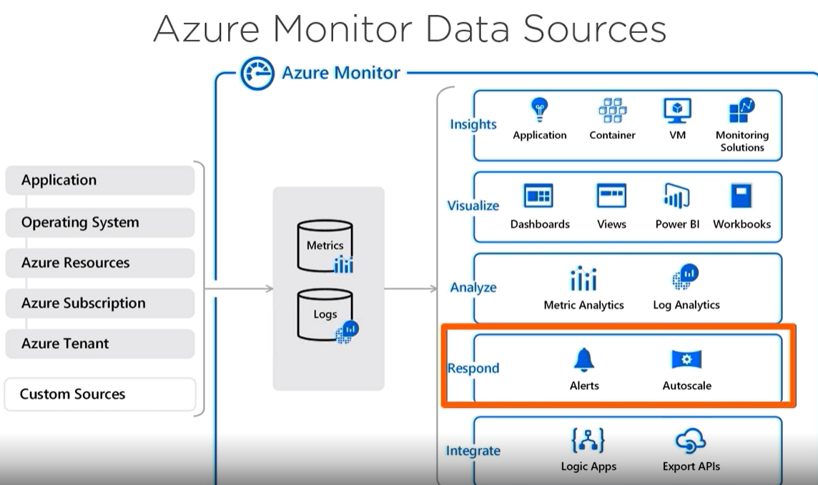

Diagnostic setting – logs and metrics can be sent to: (destination)

Log analytics workspace – paas for diagnostics and logs

Eventhub

Storage account

VM agent – VM diagnostic extension, log analytics agent, dependency agent

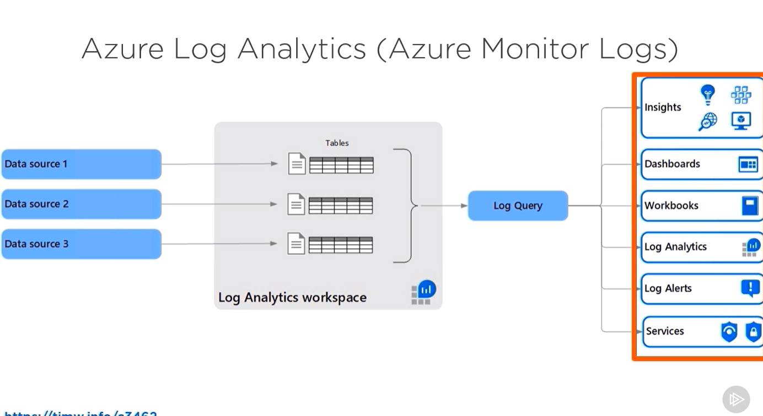

To create a log analytics workspace  
Go to Log analytics > Create

To create a monitor

Go to Monitor > Diagnostic setting > choose resource > add a diagnostic setting > choose destination

**Implement backup and recovery**